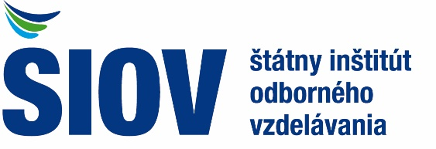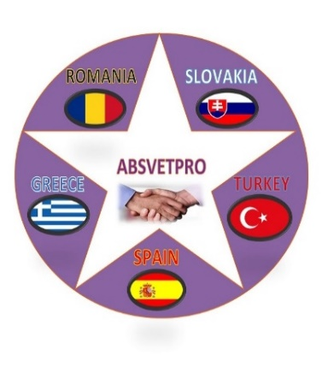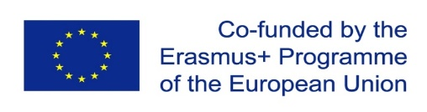

INVITATION TO ERASMUS+ PROJECT ABSVETPRO MEETING
To Whom It May Concern
State Institute of Vocational education and Training (Statny Institut Odborneho Vzdelavania), Bratislava, Slovakia, hereby invites you as the representatives of ABSVETPRO partner organisation, to participate in the working meeting in the Erasmus+ KA-202 Strategic Partnership Project: “ Reducing Absenteeism Through Teamwork, Motivation and Insertion of Immigration”, Project No: “2019-1-ES01-KA202-065847”.
The formal meeting will be held from 26th of February 2020 to 27th of February 2020 (during 2 days) in Bratislava - Slovakia.
We are looking forward to welcoming you to our country.
Bratislava, 07.02.2020

SIOV manager and ABSVETPRO project coordinator in Slovakia
SATKA Ladislav
SIOV Bratislava
Bellova 54/a, 837 63 Bratislava 37
Mobil. Tel.: +421 903 469 766
e-mail: ladislav.satka@siov.sk
web: www.siov.sk

