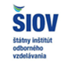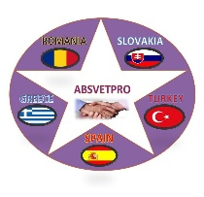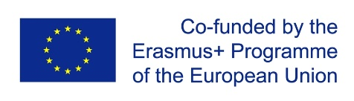
Project ABSVETPRO
Project Meeting - Slovakia – Bratislava 26. – 27.2.2020
Venue and Program
Venue: SIOV - Statny institut odborneho vzdelavania – State Institut of Vocational Education and Training - Staatliches Institut für Berufsbildung ( www.siov.sk ) Stromova Street. 9, 1.st floor, Meeting Room 11.148 Bratislava - Kramare. Visual of the place (building of the SIOV) is enclosed in attachment. Location – Map (object on the map 3), some program will take place outside of the SIOV in the city center and the school visit at the suburb of the city (we travel by public transport approximately 45 min.).
Program
26.02.2020 Wednesday
9:30 | Registration and Beginning | SIOV, Stromova Str. 9, BA
9:30 - 10:00 | Info – Input | SIOV - Hazuchova, Satka
10:00 – 10:30 | Slovak centre of training Firms – SCCF (best practices in Slovakia) | SIOV - Horecka
10:30 – 12:30 | Project activities | IES - Julio Sancho, Carmen Domingo
12:30 – 13:30 | Break – lunch
14:30 – 15:30 | IOM Migration Information Centre (MIC) Slovak Republic | IOM Mr. Slama  Grösslingová Str. 35, 811 09 Bratislava
Afternoon | Visit Bratislava
 | Possibility of dinner

27.022020 Thursday
9:00 | Beginning | SIOV, Stromova Str. 9, BA
9:00 – 10:30 | Project activities and new tasks | IES - Julio Sancho, Carmen Domingo
10:30 -11:30 | Experiences with the migration and education – Nadácia Milana Šimečku | FMS – Gallova, Kriglerova, Weberova
11:30 – 12:00 | Dual education in Slovak Republic and SIOV (best practices) | SIOV – Mr. Kuzma
12:00 - 14:30 | Break and transfer
15:00 - 16:30 | Dual Academy (best practices of the dual education in Slovakia) | Dual Academy Bratislava, Jana Jonáša Str. 6179/5, 843 06 Devínska Nová Ves
16:30 - 17:00 | Conclusion

