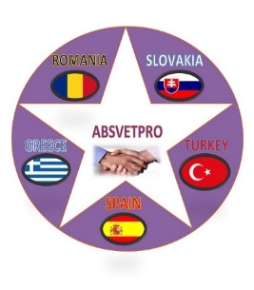
Information
Value added tax in the Slovak Republic
Value added tax is one of indirect taxes and is, by its nature, a universal consumption tax. It represents one of the largest revenues of the state budget. Value added tax is harmonised at EU level and is regulated by Council Directive 2006/112/EC on a common system of VAT, which contains all the mechanisms for the functioning of the VAT system.
The Slovak Republic has transposed this Directive into its legal order by Act No. 222/2004 of Value Added Tax, as amended.
Tax rates:
Tax on 20% - this is the basic VAT rate applicable to all goods and services not subject to a reduced tax rate of 10% - this is a reduced VAT rate applicable to the goods and services referred to in Section 27(2)(a) and (b)(.b) of the VAT Act.
The difference from last years is in the extension of the reduced VAT rate to new types of goods.
New types of goods – printing and healthy foods with a reduced VAT rate From 1 January 2020, a reduced VAT rate of 10% applies to new types of goods that can be classified in two categories:
- newspapers, magazines and periodicals,
- healthy foods according the definition under Act No. 152/1995
SATKA Ladislav
SIOV Bratislava
Bellova 54/a, 837 63 Bratislava 37
Mobil. Tel.: +421 903 469 766
e-mail: ladislav.satka@siov.sk
web: www.siov.sk
