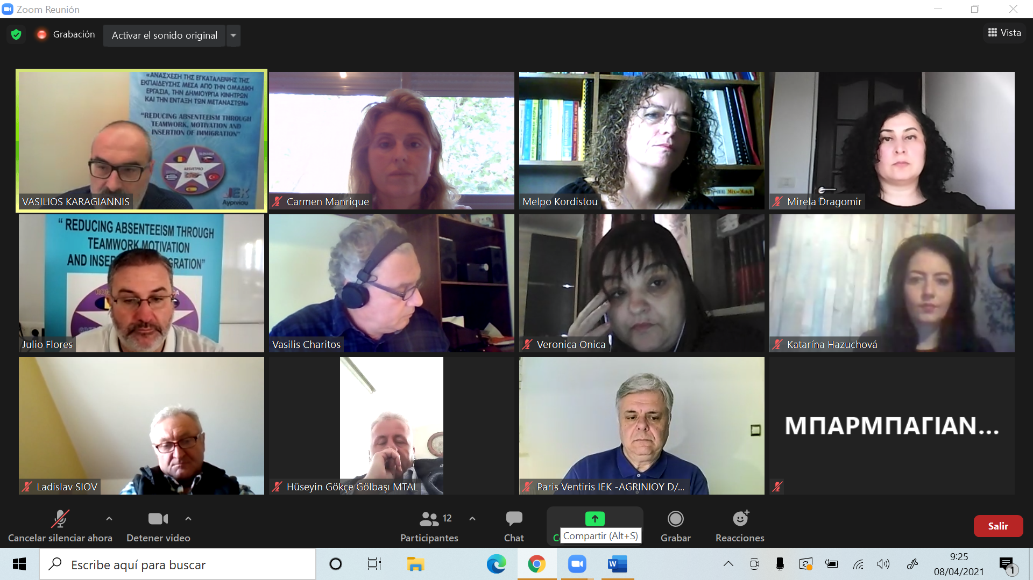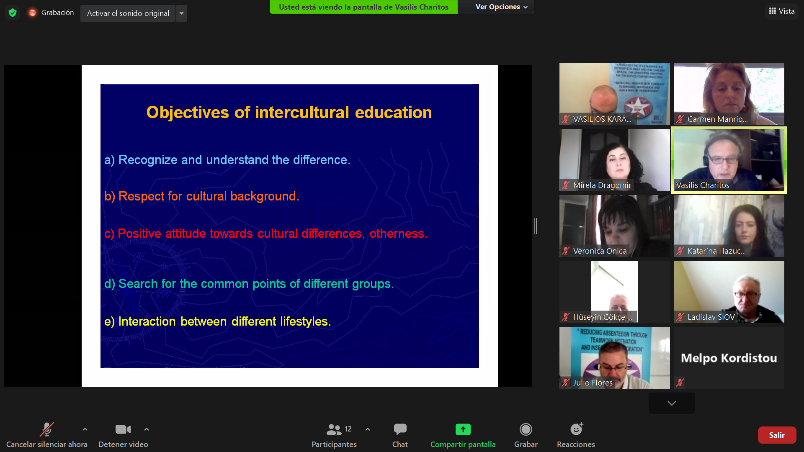10:50 -11:10 Discussion with the teachers of DIEK about their professions and the way of teaching adults at risk of absenteeism and integration of immigrants. Short video with activities of DIEK
10:50 -11:10 Discussion with the teachers of DIEK about their professions and the way of teaching adults at risk of absenteeism and integration of immigrants. Short video with activities of DIEK
