 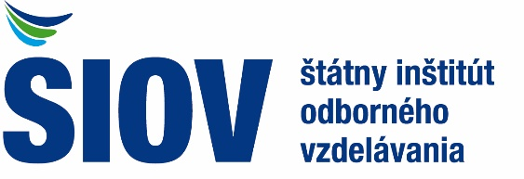 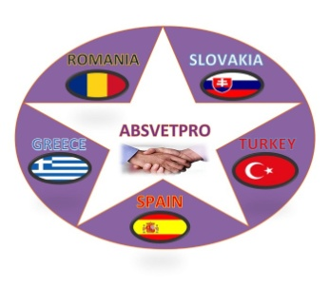

|  |  |  |  |  |
| --- | --- | --- | --- | --- |
| **DATE** | **DISSEMINATION ACTIVITY** | **TARGET GROUP** | **NO OF RECIPIENTS** | **Proofs of dissemination** |
| DISSEMINATION ACTIVITIES | | | | |
| From January 20 | **WEB Page ŠIOV with information about ABSVETPRO project** | SIOV WEB visitors |  | Link:  Projekt ES - ABSVETPRO - ŠIOV - štátny inštitút odborného vzdelávania (siov.sk) |
| From February 20 | Installation of the Information board (panel) about project activities in SIOV organisation | Staff and visitors of the SIOV organization |  |  |
| Regularly once a month | Informing of the head and collaborators SIOV staff in departament about international project activities | Staff SIOV |  |  |
| From March 21 | Information Banner in Slovak language | Staff SIOV and visitors SIOV |  |  |
| February 27, 2020 | „Second Project meeting in Bratislava – First Day” organized by Slovak partner post on the social media Facebook | Public |  |  |
| February 27, 2020 | „Second Project meeting in Bratislava – Second Day” organized by Slovak partner post on the social media Facebook | Public |  |  |
| February 13, 2021 | „Virtual Conference” post on the social media Facebook | Public |  |  |
| March 15, 2021 | „Virtual Conference” post on the social media Facebook | Public |  |  |
| April 16, 2021 | „Third Project meeting” organized by Greek partner post on the social media Facebook | Public |  |  |