[](about:blank) **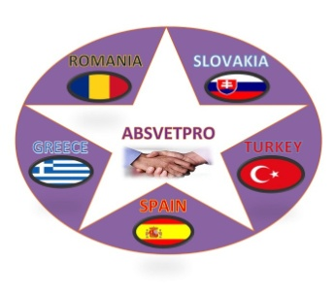**  ****

**Turkey Dissemination Diary**

**(Gölbaşı Mesleki ve Teknik Anadolu Lisesi, Ankara / TURKEY)**

|  |  |  |  |  |
| --- | --- | --- | --- | --- |
| **DATE** | **DISSEMINATION ACTIVITY** | **TARGET GROUP** | **NO OF RECIPIENTS** | **Proofs of dissemination** |
| DISSEMINATION ACTIVITIES CARRIED BY GOLBAŞI MTAL SO FAR | | | | |
| December  2019 | Project Banner on the wall of Gölbaşı VET School (size: 2mx1.5m ) | School staff  Students  School visitors | - | **Banner_foto.jpg** |
| January  2020 | Project ROLLUP in the entry of of Gölbaşı VET School | School staff  Students  School visitors | - | **I:\1_ispanya\dissemination\rollup foto.jpg** |
| 1019-- | We have given information about the ABSVETPRO project in our school Erasmus+ Corner | School staff  Students  School visitors | **-** | IMG_20180406_121058263 |
| 2019---- | Publication of a description of the project, link to the project website, meetings in Gölbaşı MTAL’s Website.. ( [http://golbasimtal.meb.k12.tr/tema/](about:blank) ) | Public in general | 700 students and their families follow the website |  |
| 2019---- | Creation and Publication, Updating of ABSVETPRO facebook group.  ([https://www.facebook.com/groups/555761855027000](about:blank) ) | Public in general | All social media users |  |
| January  2020 | Meeting with all school staff | School staff | 75 | C:\Users\Casper\AppData\Local\Microsoft\Windows\INetCache\Content.Word\IMG_20180618_103501705.jpg C:\Users\Casper\AppData\Local\Microsoft\Windows\INetCache\Content.Word\IMG_20180618_102825965.jpg |
| May 2020 | We prepered the ABSVETPRO Stock Control Program  Training video for it: ([https://www.facebook.com/huseyin.gokce.963/videos/2946647782127905](about:blank) ) | Public in general | Free of charge |  |